|  |  |
| --- | --- |
| **Project – External Documentation** |  |
| COMP6114  Pattern Software Design |
| *Even Semester Year 2022/2023* |

* Project Title

KpopZtation

* Introduction

KpopZtation is a K-pop album shop website where people can find information about the K-pop album and order it. This website enables the customers to know what is inside KpopZtation. KpopZtation is developed using ASP .NET and Domain Driven Design consisting of a View, Controller, Handler, Repository, Factory, and Model layer.

* Report / Documentation

1. Login page

This page is only accessible to guests when the user will attempt to log in to the website. There are two textboxes: email and password. There is validation that email and password must be filled and appropriate with the data in the database. This page also implemented cookies (if the user checks the remember me checkbox) and sessions. We already prepare 2 credentials to make your correction easier:

|  |  |  |
| --- | --- | --- |
| Email | Password | Role |
| natasha@gmail.com | natasha | Customer |
| admin@gmail.com | admin | Admin |

1. Register page

This page is only accessible to guests, where users can register themselves as a customer. There is validation for the input such as all textboxes must be filled, the name must be between 5 and 50 characters, the email must be unique, the gender must be selected, the address must end with “Street”, and the password must be alphanumeric. After the data is inserted into the database, the page will redirect to the login page.

1. Home page

This page allows the admin and customer to see all artists' data such as id, name, and image.

Admin

Admin is allowed to insert, update, delete, and see artist details. If the admin clicks the delete button, the artist's data will be deleted. If the admin clicks the edit button, it will redirect to the update artist page. If the admin clicks the insert link, it will redirect to the insert artist page. If the admin clicks the detail button, it will redirect to the artist detail page.

Another user

Customer cannot insert, update, delete artist. Customer only can see artist detail.

1. Artist detail

Admin

This page displays selected artists’ data and albums. Admin can insert, update, delete, and see album details.

Another user

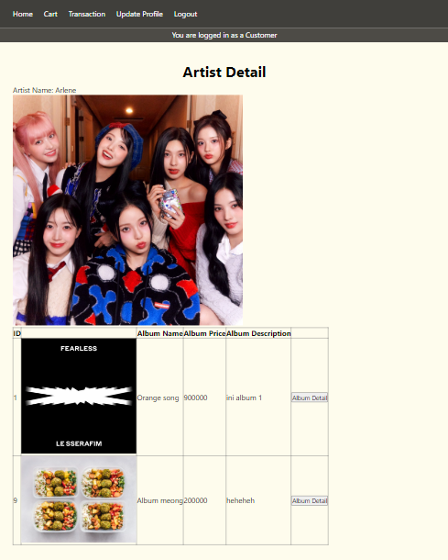

The customer cannot update, delete, or insert album data. Customers only can see album details by clicking the detail button.

1. Insert artist

This page is only accessible to the admin, where the admin can insert a new artist into the database. The fields have validation such as all data must be filled, the name must be unique, and the image extension must be .png, .jpg, .jpeg, or .jfif, and the file size must be lower than 2MB.

1. Update artist

This page is only accessible to the admin, where the admin can update existing artists in the database. All the data will be shown on this page, and the admin can change the data before submitting it again. The fields also have the same validation as the insert page.

1. Insert album

This page is only accessible to the admin where the admin can insert a new album for the selected artist on the artist detail page. The fields have validation such as all fields must be filled, name length must be shorter than 50 characters, the description must be shorter than 255 characters, the price must be between 100000 and 1000000, the stock must be more than 0, and image extension must be .png, .jpg, .jpeg, or .jfif, and the file size must be lower than 2MB.

1. Update album

This page is only available for the admin where the admin can update an existing album in the database. All the album data will be shown on this page, the admin can change the data before submitting it again. The fields have the same validation as the insert page.

1. Album detail

This page shows album data such as name, image, description, price, and stock.

Customer

Customers can add the album to the cart by inputting the quantity. The field also has validation that quantity must be filled and can’t be more than the stock album. If the item is already in the cart, the quantity will be updated with the new quantity.

Another user

Admin and guest cannot add the album to the cart, therefore, there is no add to cart button.

1. Cart page

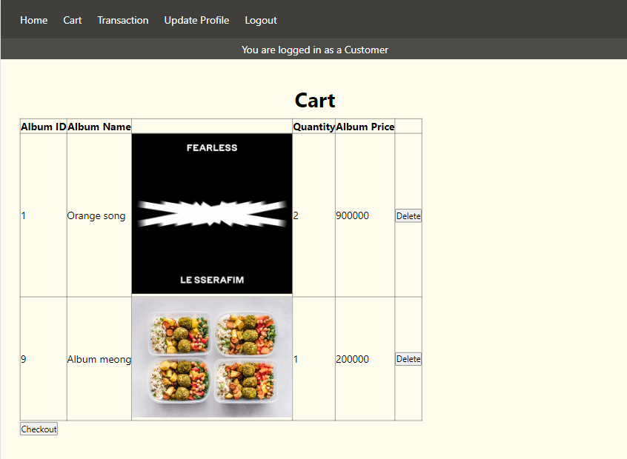

This page is only accessible to customers, where customers can see the album id, album name, album image, quantity, and album price that they put into the cart. There is also a delete button to delete individual album data in the cart, and a checkout button, where the cart data will be moved to the transaction history page.

1. Transaction history

This page is only accessible to customers where customers can see their transaction history such as id, date, customer name, album image, album name, quantity, and album price. Transaction history is the albums that customers have checked out.

1. Transaction report

This page is only accessible to the admin where the admin can see all transactions that have been made by all customers. This page uses Crystal Report and shows transaction id, customer id, transaction date, total value, transaction id, album name, quantity, album price, and subtotal value.

1. Update Profile

This page is only accessible to admin and customers, where they can change their profile information. All data will be shown on this page, and they can change their data before submitting it again. This page has the same validation as the registration page.

1. Logout



If the admin or customer clicked the logout button, the cookie and session will be cleared, and the user will be logged in as a guest.

* Reference
* No reference was used in this project.
* Group Member
* 2540103055 – Natasha Grace Radika
* 2540125850 – Findy Febrianne
* 2540126216 – Juan Wira Lukmarda
* 2540126430 – Valentinus Gilbert Sanjaya